Blood Center Logo’s - ONSITE

- Login Page:

Renamed WS_Blood_Centers_Aligned.png to WellSky.png

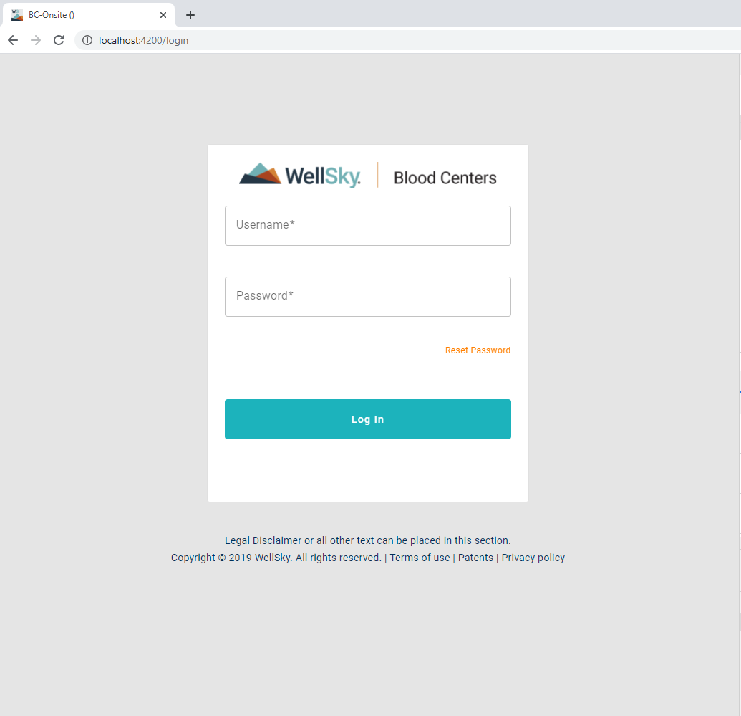

- Fav icon (32 x 32)

Renamed WellSkyFavicon_32x32
To
favicon.ico



- Drawer menu:

Renamed WellSky®_Aligned_Outlined_White_RGB.png to WellSkyWhite.png

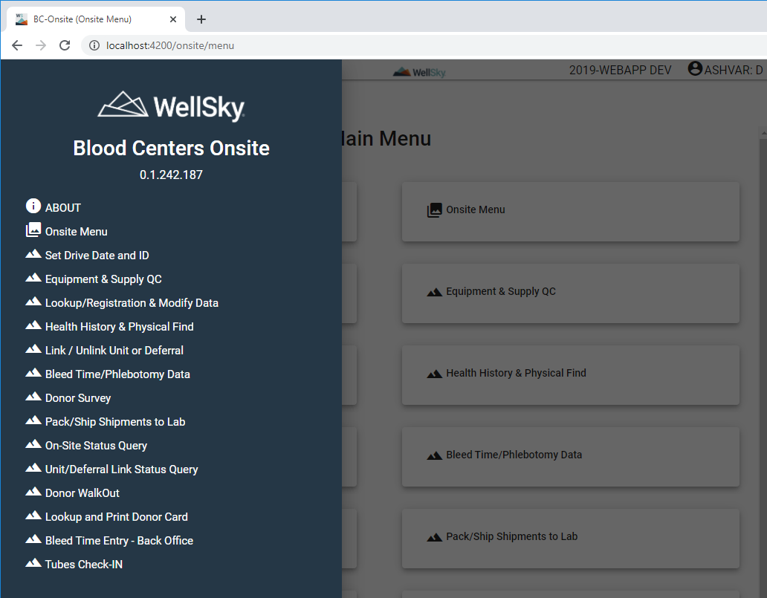

- Top banner image.

Renamed WellSky®_Aligned_Color_RGB.png to ws_logo_hz_rgb_pos.png

Resized from 4335 px x 1502px to 90 px x 32 px

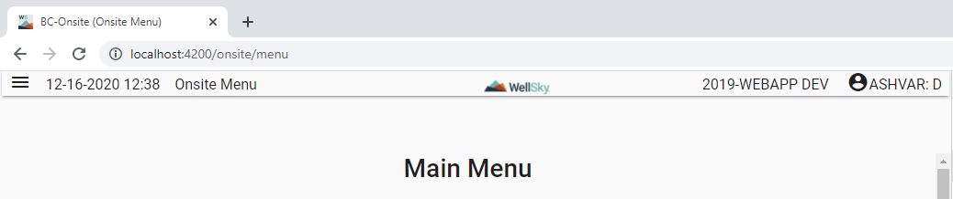

ADDITIONAL INFORMATION:

Location of images:
BCOnsiteUI\src\assets\images\

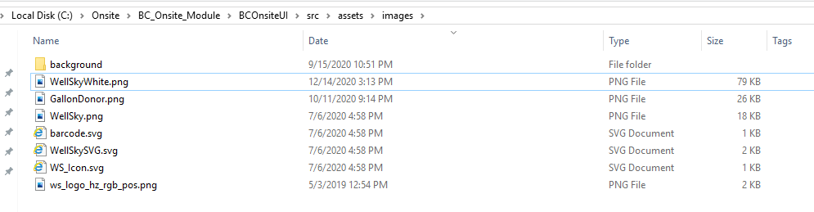 vbc

